Certificates and forms

A green form will be issued and sent electronically to the funeral director by the Registrar after your appointment. Other procedures may apply if the death has been referred to the coroner.

Death certificates cost £11.00 and can be purchased during your appointment.

You can order more certificates should you need them at any point in the future.

Order copy death certificates online at

warrington.gov.uk/certificates

Comments and complaints

Should you have any comments to make about your visit to the register office you can:

- speak to the Superintendent Registrar
- write to the Proper Officer for the registration service
- Or complete a ‘feedback form’ available at the main reception area of the Warrington Borough Council building.

Our location

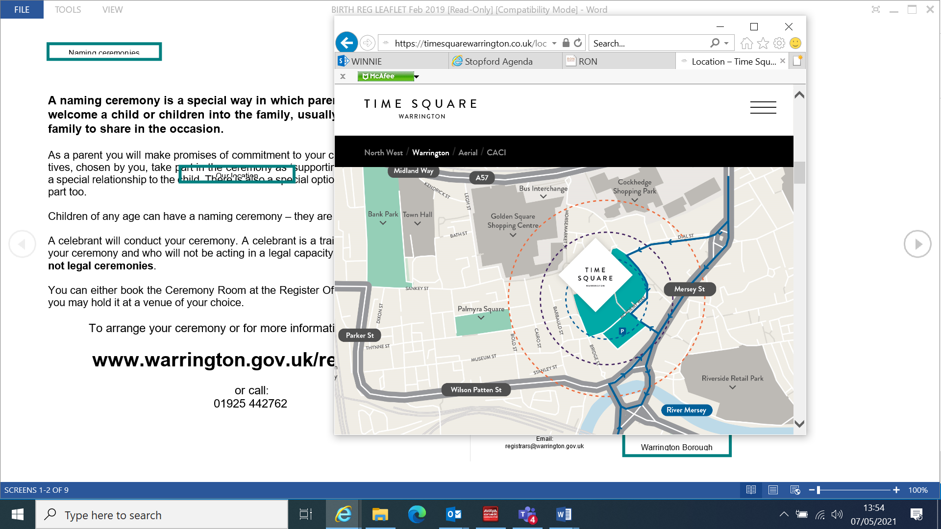
The Register Office
1 Time Square
Warrington
WA1 2NT

Tel: 01925 442194
Fax: 01925 442739
Email: registrars@warrington.gov.uk
Web: warrington.gov.uk/death
(for more information)

Parking is available within the Time Square multi-storey car park located at the rear of the building. Parking fees will apply.
Registering a Death



Helpful Information

Warrington
Registration
Service

warrington.gov.uk/registrars


When does a death need to be registered?

A death must normally be registered within 5 working days unless the coroner is conducting an investigation into the circumstances surrounding the death.

Where should I register a death?

Deaths must be registered in the district in which they occur. For deaths occurring in Warrington this is:

The Register Office
1 Time Square
Warrington
WA1 2NT

01925 442194

Once we have received the relevant paperwork, a Registrar will telephone you to book a face to face appointment which will last approximately half an hour.

Alternatively, you may contact any other register office in England and Wales to make a ‘declaration’. They will send the information you give there to the Registrar at Warrington by email. You must then order certificates online. This procedure may take several days to complete.

Who may register a death?

A close relative of the deceased should register the death. If this is not possible please call the register office for advice. Please note that due to the size of our offices, a maximum of 2 people may attend to register the death. We apologise for any inconvenience this may cause.
Who may register a death?

What should I have available for the appointment?

Unless the coroner has decided a post mortem is necessary, a medical certificate must be provided by the General Practitioner, hospital or hospice before an appointment can be made. This however, is sent directly to the Registrar’s so you will not be required to collect it and bring it to us.
What information will I need to know?

- the deceased’s date and place of birth
- their full name and maiden name, if a married woman
- their occupation, and if a married woman or widow, the full name and occupation of her husband
- their home address
- if married, the date of birth of the surviving widow or widower

To help ensure the accuracy of the information recorded, it would be useful if you could refer to any supporting documentation for the deceased such as:

- Passport
- Driving Licence
- Utility Bill
- Birth Certificates
- Marriage / Civil Partnership
Certificates
- NHS Medical Card
- Name Change Documents

Please do not worry if any of these documents are not available as the Registrar can still proceed to register the death without them.

The Register

It is important that the information recorded in the death register is correct. It is a legal record which becomes difficult to correct at a later date and will incur a charge. The Registrar will do their upmost to carefully guide you through the register entry but it is ultimately your responsibility to provide the correct information and check carefully before signing the register page.

